Risby Preschool Summer Newsletter 2025





Summer Clothing & Sun cream

Please ensure your child comes to Preschool with a sun hat to protect their heads from getting too hot outside in the garden. Please NAME their clothing including their sun hats.
- 

Please ensure your child comes in the morning with sun cream applied to be fully protected from the sun rays. If your child attends preschool all day please can you give staff a named bottle of sun cream which staff will reapply sun cream after lunch to your child only.

Water Bottles & Lids

If you wish to purchase a new water bottle or lid please ask a member of staff. A new bottle and lid is £1.50 or a lid on its own is 50p.

Please can you clearly name your child’s following items

- Coat
- water bottle
- lunch box/bag
- items of clothes if possible



Please do not leave inhalers & medicines in your child’s bag on the coat stand as we need to safeguard all children from having access to medicines whilst in the setting. We can only administer prescribed medication from a doctor so please give to a member of staff who will place it in our medical box away from the children and ask
They will need to be clearly labelled including name, DOB and dose to be given.

Child Illness

If your child is ill, please give us a ring during the session, just to let us know why they are absent.

If you child has a bout of diarrhoea or a vomiting bug please notify staff straightaway. You will need to keep your child away from Preschool for 48 hours after last incident which will help stop spreading the virus to others. This is the recommendation from the Health Protection Agency.

Child Absence

When your child will not be in for a session due to holidays/appointment please can you send us an email risbypreschool@hotmail.co.uk as this helps us with future planning for your child. Thank you!

Concerns

If you have any concerns about your child or wish to discuss anything, please talk to the member of staff at the Preschool door in the morning or at the end of a session. If you would prefer to talk privately then please let us know and we will arrange somewhere private to talk at a convenient time



Children’s Library in foyer

You are welcome to take one of our books from the library box in the foyer and share this with your child at home. When you are finished reading the book please return it to the box and your child may then choose a new book. Please log the book number and title next to your child’s name on the sheet of paper with the books. When returned please put a line through the book number and title.

Barty Bear

Each child will have an opportunity to take home ‘Barty Bear’ for a sleepover for one night. He is our teddy bear who comes with his own items in a rucksack i.e., clothes, pyjamas, toothbrush, passport and log book.

If the parent can write in the log book what Barty Bear has done with the child whilst staying at their home and then when Barty returns back to Preschool a member of staff will read out to the other children all the things he has been doing.

Our typical day at Risby Preschool
9.00am – Preschool opens
The children are greeted by a member of staff at the door, who encourages them to walk independently into the preschool room.
The children are supported to put their coats on the peg and place their water bottles on the shelf, to find their name on the table and to go and play.

9.00am-3.00pm - Free flow play outside and inside
Our Preschool children have the opportunity to have continuous play both inside and outside from 9.00am to 3.00pm. We have a rolling snack so the children choose if they stop their play to come and eat/drink.

Our staff follow ‘In the moment planning’, so children choose where their learning takes place and is based around the child’s interests and choice. The staff will observe what the children are doing, assess what they need to do/know/learn next and plan their teaching, which will be delivered there and then. This means next steps for individual children are not something that will be delivered at a point in the future, but right there ‘In the Moment’.

11.00am - Group carpet time
The child and staff all sit together and sing nursery rhymes with the help of Felix and Frieda our soft cuddly foxes. This is also an opportunity to go through our preschool rules and to see what Barty Bear has done at a sleepover at a child’s house (all children take it in turns to take Barty home with them for one night and bring back to the next morning)

11.55am – Lunch time
The children staying for lunch will all sit down with a member of staff and eat their lunch together. Once they have finished, they are encouraged to independently put their lunch box away and then continue with playing.

Indoors - We have various activities on the tables and mats around the room
Examples are: small world play, playdough, sensory table, construction equipment, maths equipment, ICT equipment, kitchen role play, dressing up clothes

Outdoor – The children have a choice out activities and equipment that are all out to play with every day.
- bikes/ride-on’s - balancing equipment - mud kitchen
- builders /construction site - water play
- sand tray - bubbles - climbing frame

Afternoon activity – Phonics activity
Key person weekly Theme. Each week your child will be taught by their key person about a different theme throughout their play. For example about Garden Birds, Recycling, Oral Hygiene, People that helps us, Sea and Oceans, Farm animals, Life cycle of a frog and many more.

Home with them for one night

Risby Preschool Logo Clothing, Hats and Bags

You can now purchase any of Risby Preschool sweatshirts, polo shirts, t-shirt, bags and sun hats online with a local printing company and they will be delivered free to preschool for you to collect.

Sweatshirt £10.95 Child’s Polo-shirt £7.99
Child’s T-Shirt £5.45 Navy Rucksack £10.95
Navy Drawstring Bag £5.95 Legionnaires Hat £4.95
Junior Book bag £7.99

Order instructions

Log onto corporatetiger.co.uk
Click on ‘Schools/clubs’ tab
Find Risby Preschool and double click
Select items you wish to order
Click on FREE local collection and your items will be delivered to Preschool

- 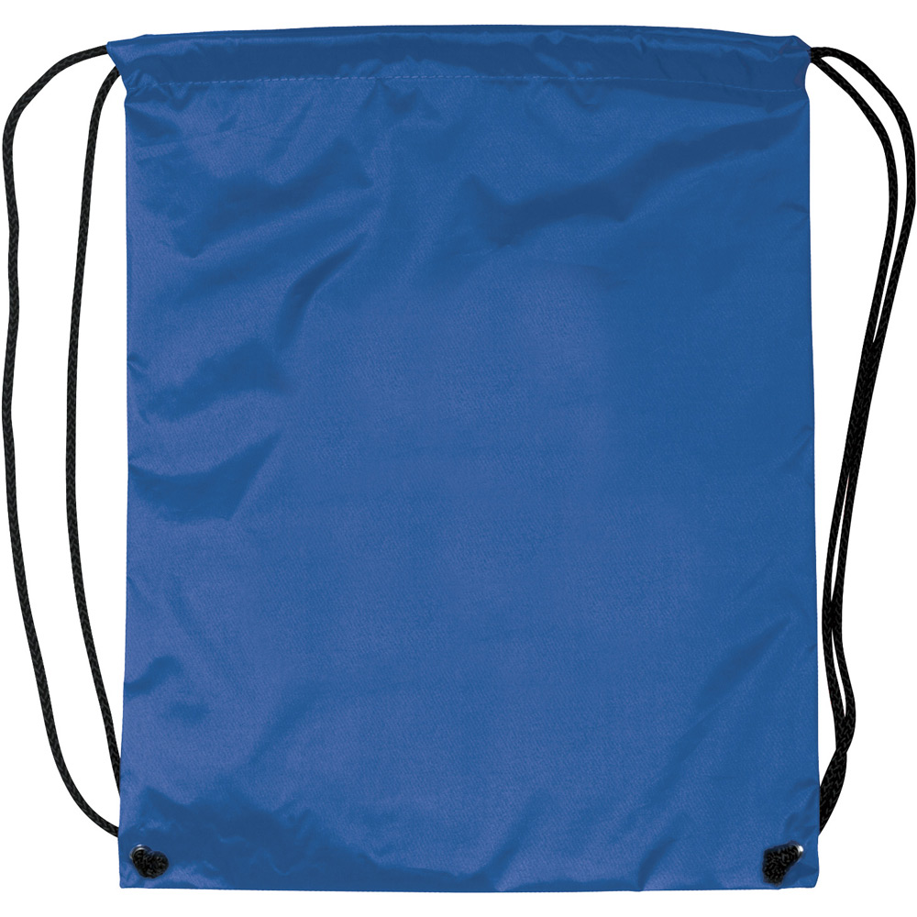

Ideas to help prepare your child for Primary School
To help prepare your child ready for Primary School it would be beneficial to practice:
- Resolve conflict themselves between their friends
- recognise their own name as these will be on their school coats and belongings
- General Independence for example in toileting and washing their own hands
- Being able to put their own shoes and coat on
- Listening skills
Your child does not need to be able to write their name or know the phonics letter sounds. Please do not put that pressure on yourself or the children, they will learn this at school.

Our Prices for All Services up to Sept 25

 | Permanent  Pre-Booked | Block or Ad-hoc Bookings
Early Birds 8am-8.45am | £9.75 | £10.25
Early Birds Preschool Child 8-9am | £9.25 | £9.75
Preschool 8.45-9am | £3.25 | £3.75
Preschool 9.00am-12pm | £19.00 | £19.50
Preschool 9.00am-3pm | £38.00 | £39.00
Lunch Club 12pm-1pm | £6.50 | £7.00
Preschool 3-3.30pm | £6.50 | £7.00
After School
3:20pm - 4:30pm | £9.25 | £9.75
3:20pm – 5:00pm | £11.25 | £11.75
3:20pm – 5:30pm | £13.25 | £13.75
4.30pm – 5.00pm | £6.50 | £7.00
4.30pm - 5.30pm | £9.25 | £9.75
Extra 1/2hr |  | £7.00
Extra 1hr |  | £9.75
Late fee after 5.30pm (every 15mins) |  | £15.00

Bank Account Number: 00019281 Sort Code: 40-52-40
Please quote your Child’s Name as reference

Summer Term Dates 2021

Summer Term 2025
Tuesday 22nd April First Day of School
Monday 5th May Bank Holiday
May 26th - May 30th HALF TERM
Tuesday 22nd July Last Day of School


2025-2026

Autumn Term 2025
Monday 1st September PD Day
Tuesday 2nd September PD Day
Wednesday 3rd September First Day of School
October 27th - October 31st HALF TERM
Friday 19th December Last Day of School

Spring Term 2026
Monday 5th January PD Day
Tuesday 6th January First Day of School
February 16th - February 20th HALF TERM
Friday 27th March Last Day of School

Summer Term 2026
Monday 13th April First Day of School
Monday 4th May Bank Holiday
Friday 22nd May PD Day
May 25th - May 29th HALF TERM
Friday 17th July Last Day of School
Monday 20th July PD Day

